**Lab 4: Audio Amplifier Circuit**

**Keegan** **Smith**

**Bench** 02

**Electronics** II Lab

**EECE.3120 803**

**Date submitte**d 09/21/2022

**Due date** 09/21/2022

1. **SUMMARY**

The objective of this lab is to gain experience with audio circuits and understand how they work.

1. **EQUIPMENT**

**Table 1. Equipment**

|  |  |  |
| --- | --- | --- |
| **Equipment Type** | **Details** | |
| * Oscilloscope | *Make:* | Tektronix |
| *Model:* | MDO3014 |
| *Serial Number:* | CO44915 |
| * Digital Multimeter | *Make:* | Keithley |
| *Model:* | 2110 5½ |
| *Serial Number:* | 8007691 |
| * DC Power Supply | *Make:* | Keithley |
| *Model:* | 2231A-30-3 |
| *Serial Number:* | Unable to acquire |
| * Function Generator | *Make:* | Tektronix |
| *Model:* | AFG1022 |
| *Serial Number:* | 1731386 |
| * Analog Discovery | *Make:* | Digilent |
| *Model:* | Analog Discovery 2 |
| *Serial Number:* | 210231B0DF82 |
| * Handheld Digital Multimeter | *Make:* | Tenma |
| *Model:* | 72-9385 |
| *Serial Number:* | H200487467 |
| * Breadboard * Bench “Shoebox” with connector cables, adapters, clips etc. | N/A | |

**Table 2. Components**

|  |  |  |
| --- | --- | --- |
| **Component Type** | **Quantity** | **Details** |
| Audio Speaker | 1 | 8-Ohm, 2 Watt, 0.3-9KHz |
| Low-Voltage Audio Power Amplifier | 1 | LM386N-3 |
| Low-Power Dual Op-Amp | 1 | LM358 |
| Resistor | 1 | 10 Ω |
| Resistor | 2 | 2.2k |
| Resistor | 8 | 10k |
| Resistor | 2 | 100k |
| Resistor | 1 | 10k |
| Resistor | 1 | 20k |
| Capacitor | 1 | 470 μF |
| Capacitor | 1 | 100 μF |
| Capacitor | 2 | 10 μF |
| Capacitor | 4 | 1 μF |
| Capacitor | 1 | 0.033 μF |
| Capacitor | 2 | 0.022 μF |
| Capacitor | 1 | 0.1 μF |
| IC | 2 | 1N4148 |

1. **INTRODUCTION**

Speakers work by taking a digital signal, passing it through a coil (also called the “voice” coil) that sits inside of a permanent magnet. When the signal travels though the coil, it moves in the magnetic field from the magnet to push and pull on the cone (usually paper like material on top of a speaker). The movements of the cone in turn, move the surrounding air creating soundwaves.

Amplifiers work by placing several transistors in specific configurations with each other to increase the amplitude of the input signal. To list a few configurations there are, common-base, common-emitter, common-collector, current mirror and more.

1. **CIRCUIT DESCRIPTION**

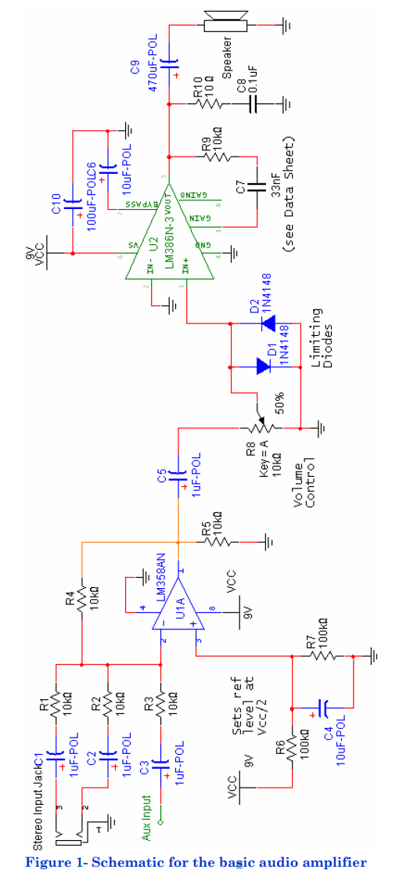

Source: “Lab 4: Audio Amplifier Circuit”, University of Massachusetts Lowell

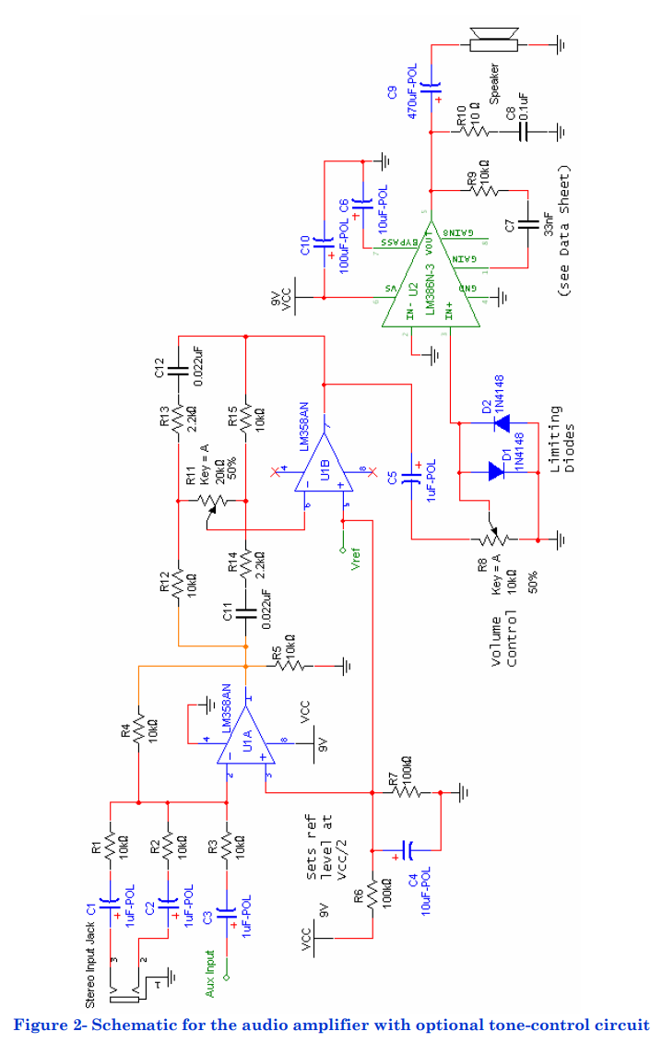

Source: “Lab 4: Audio Amplifier Circuit”, University of Massachusetts Lowell

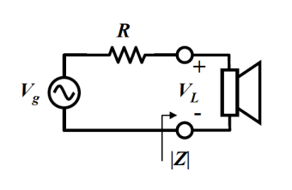

Figure 3 – Speaker test circuit

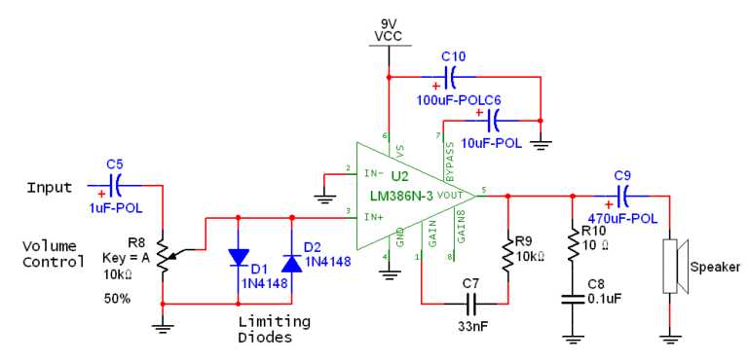

Figure 4 – LM386 Amplifier Schematic

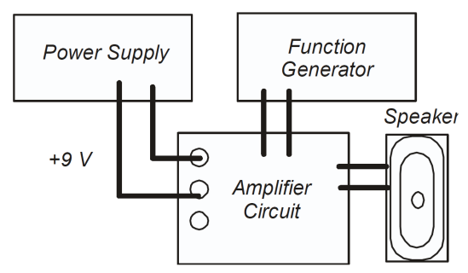

Figure 5 – Amplifier circuit Tester

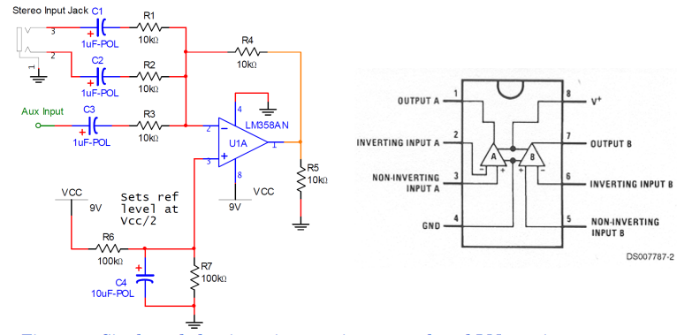

Figure 6 – Single Ended Unity-Gain Summing Network and LM358 Pinout

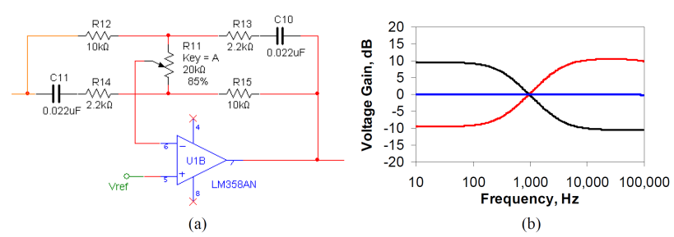

Figure 7 – (a) Single-knob tone control (b) Bode plot for tone control

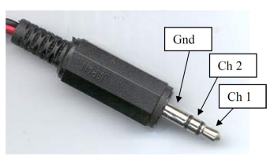

Figure 8 – Standard 3.5mm audio jack

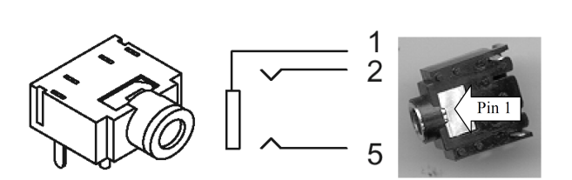

Figure 9 – 3.5mm audio jack receptacle

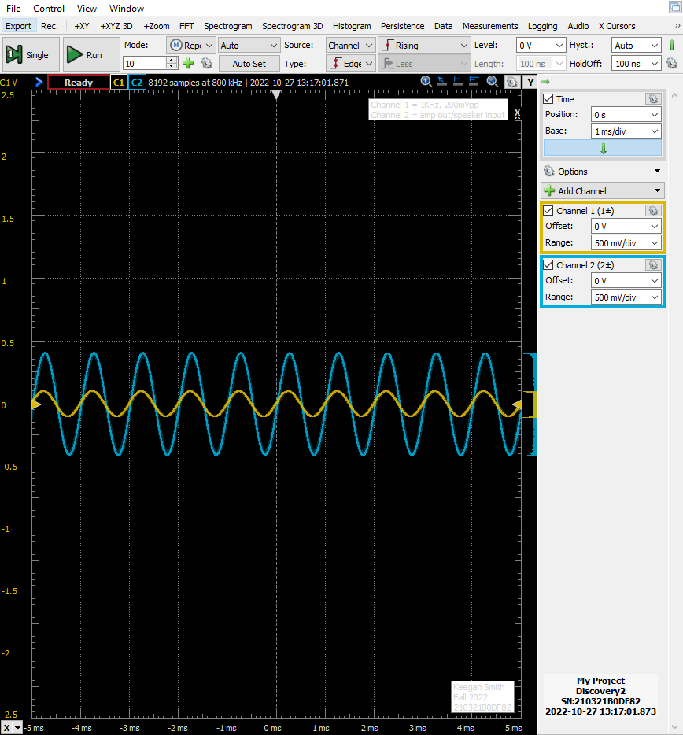 Figure 10 – Amplifier Test Circuit Part B. Output

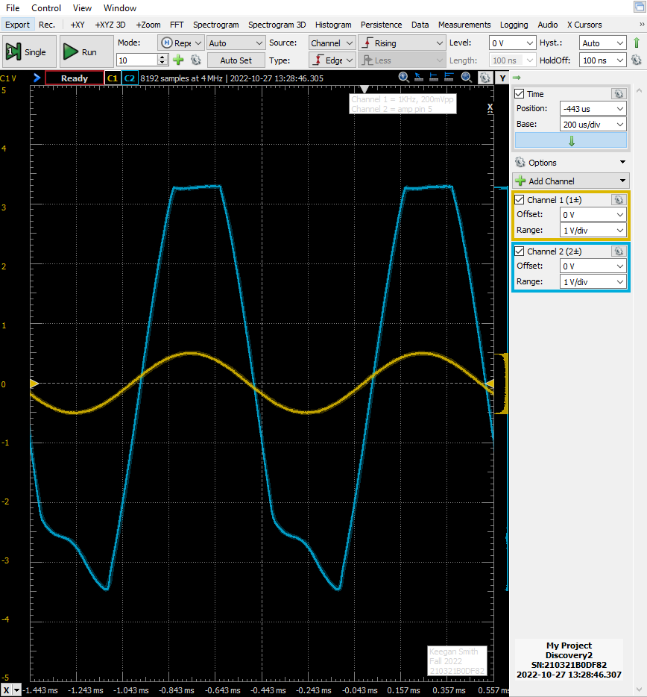

Figure 11 – Amplifier Test Circuit Part E. Output with Distortion

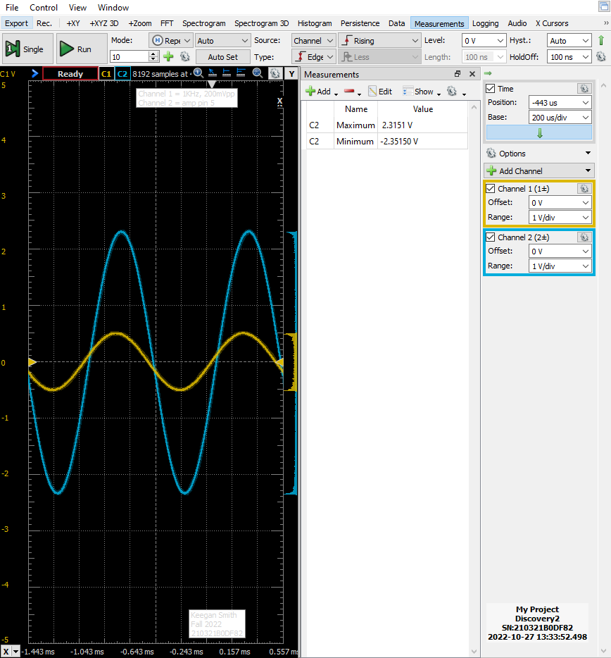Figure 12 – Amplifier Test Circuit Part E. Output with no Distortion

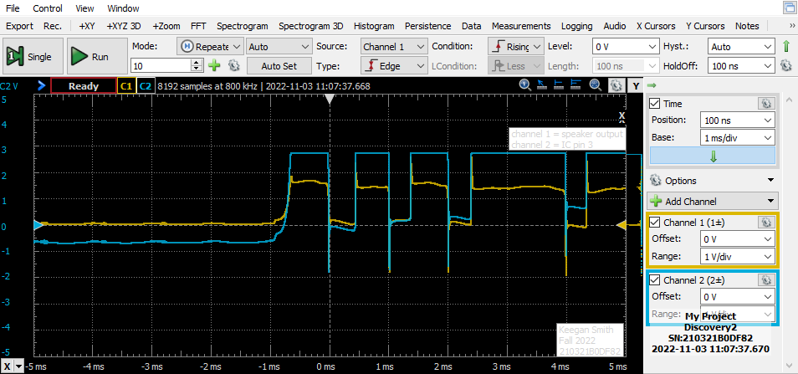Figure 13 – Amplifier Test Circuit Part F. LM386 Disconnected

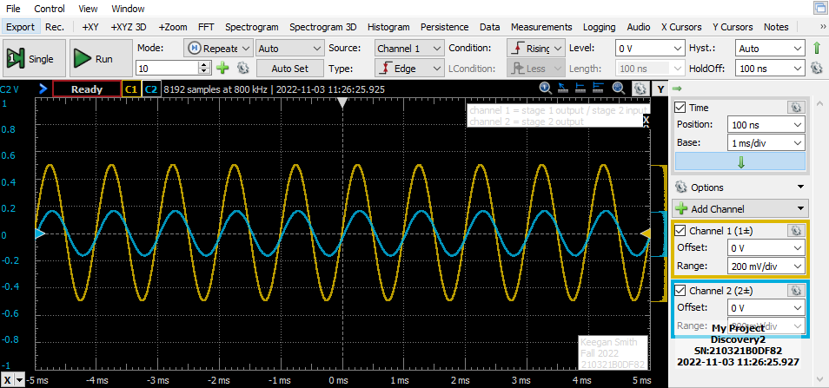

Figure 14 – Summing Network Part B.

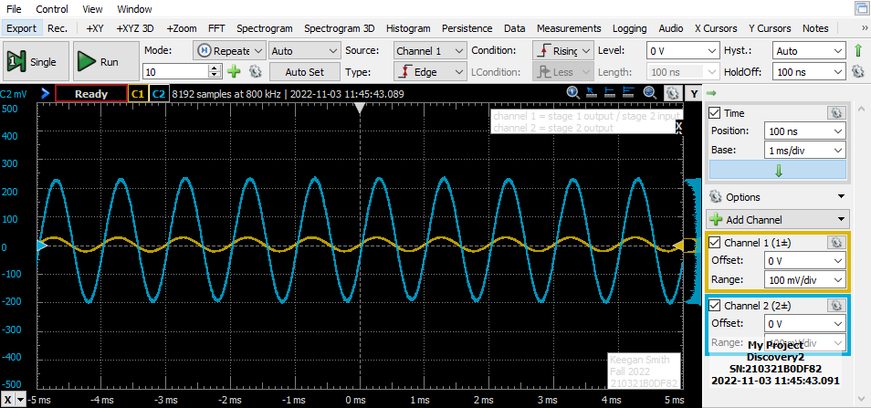 Figure 15 – Summing Network Part D.

Figure 16 – Semi-Log Speaker Impedance vs. Frequency Chart. *fs* is the “X” Coordinate

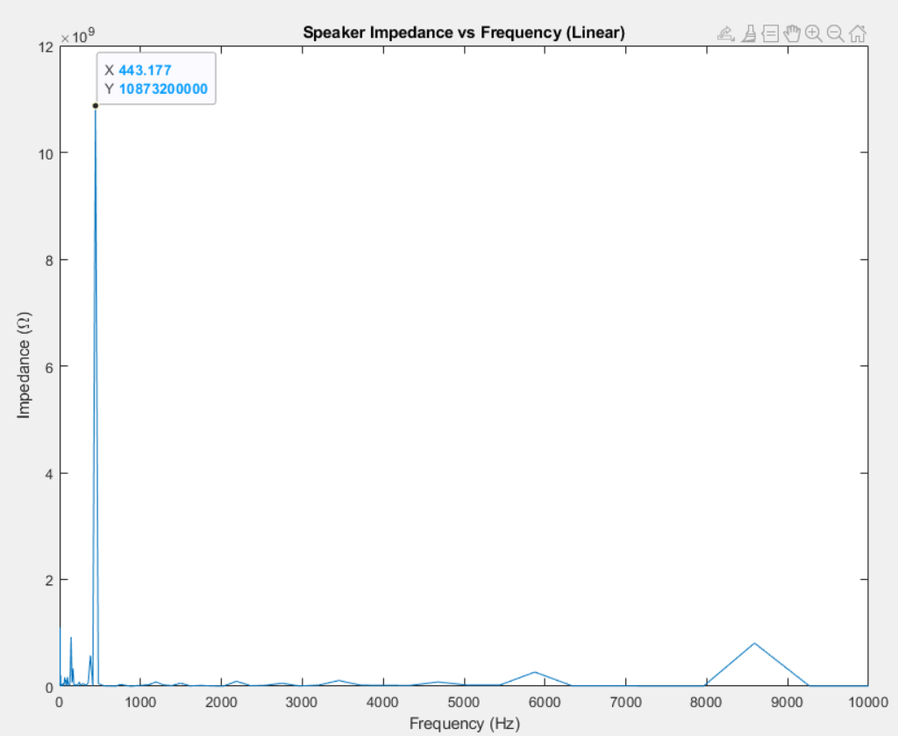 Figure 17 – Linear Speaker Impedance vs. Frequency Chart. *fs* is the “X” Coordinate

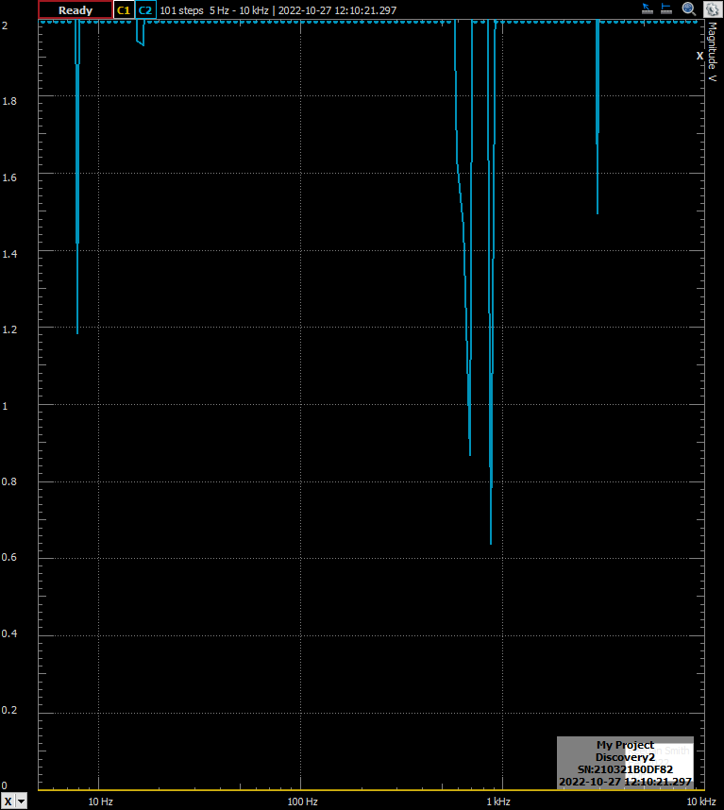

Figure 18 – Network Analyzer Results from Section 2

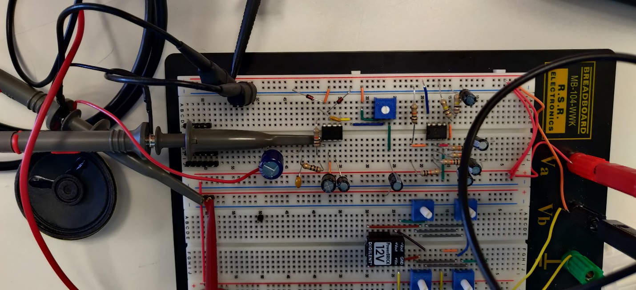

Figure 19 – Full Circuit Physical Construction

1. **MEASUREMENTS**

**Table 1 – Summing Network Parameters**

|  |  |  |
| --- | --- | --- |
| **Parameter** |  | **Calculated Value** |
| Summing network lower cut-off frequency | *flow* | 15.9155Hz |

**Table 2 – Speaker Parameters**

|  |  |  |  |
| --- | --- | --- | --- |
| **Parameter** |  | **Measured Value** | **Calculated Value** |
| Coil Resistance | *RC* | 8.346 Ω |  |
| Coil Inductance | *LC* | 73.98 µH |  |
| Free-air resonant frequency | *fs* | 443.177 Hz |  |
| Input resistance at *f = fs* | *Rt* |  | 10.873 GΩ |
| Bandwidth | *∆f* |  | 67.706 Hz |
| Q-factor | *Qms* |  | 6.54512 |
| Coil Resistance (Mechanical) | *Rm* |  | 68.89 MΩ |
| Coil Capacitance (Mechanical) | *Cm* |  | 264.2 pF |
| Coil Inductance (mechanical) | *Lm* |  | 488.1396 H |

Calculated values are dependent on measurements

**Table 3 – Summing Network output**

|  |  |
| --- | --- |
| **Amplitude** | **Current** |
| 0.025 V | 8.3 mA |
| 0.25 V | 38.8 mA |
| Under normal listening conditions | 21.16103 mA |
| **Estimated battery life at 500mAh** | |
| 23.629 hrs. | |

Results from summing amplifier section.

1. **DISCUSSION**

The first part of the laboratory experiment is to calculate the lower frequency cut off. This is done by using the following equations:

equation 1

equation 2

τ (Tao) is the time constant of a RC circuit. We solve for the constants in the summing network of the positive terminal on the op-amp, to get the ~ 16Hz low frequency cut off.

Section two performs speaker measurements with a few calculations and the impedance analyzer on the Analog Discovery. The following equations are needed:

equation 3

equation 4

equation 5

equation 6

equation 7

equation 8

equation 9

equation 10

The first step of this process was to use the impedance analyzer to measure the coil resistance, RC, and the coil inductance, LC. The next part is to use the network analyzer on the Analog Discovery to find the frequency response of the speaker. The results from this are seen in Figures 16 and 17, in linear and semi-log graphs. These were generated by taking the exported data from the network analyzer and using the supplied MATLAB code to create the graphs. After that, we are able to use equations three through nine to find the rest of the speaker’s variables.

The purpose of the third section is to build and test the LM386 amplifier circuit. This section was supposed to be performed as part of the prelab, but this was not done because the prelab was submitted early. However, the whole of the circuit system, figure 1, was constructed before the start of the experiment. Other than that, nothing else is notable in this section.

Section four is the testing of the circuit built in section three. To perform this, the power supply was connected, and the function generator was connected to the input of the circuit. The input wave was a 1kHz, 0.2V amplitude sinewave. The results of this part are seen in figure 10. Then, the lowest and highest audible tones are found. I did this by slowly decreasing or increasing the input wave to when I could no longer hear them. I found these to be 300 and 13kHz respectively. Channel 1 is the input wave from the function generator, and channel two is the output of the amplifier circuit. Next, the amplitude of the wave is increased to 0.5V at 1kHz. The results of this are seen in figure 11, where the output wave experiences clipping at the positive peak, and distortion at the negative peak of the wave. This is because the gain of the circuit may only amplify the circuit so much and operating past the maxim and minima causes loss in signal integrity. Looking at figure 12, when the volume control is adjusted, lowering the output, we see that the distortion has subsided. After that, the LM386 chip is removed from the circuit and then the circuit is powered. Looking at figure 13 we see interesting results.

The next section, section five, focuses on the summing network aspect of the circuit in figure 1. The summing portion of the circuit allows for two different types of audio input. The first is an auxiliary input, with the positive wire on the input and the ground connected to the ground of the system. The second option is the stereo jack. This has two outputs, pins two and three, and these are for the left and right channels if we were to convert this form a single channel. The summing circuit combines the left and right channels from the stereo jack, converting it to a “mono” signal so, all parts of the signal are amplified and output to the singular speaker. Having a summing network enables the circuit to have the different input options. For parts b though e, the current of a 1kHz sinewave is inputted at with the aux input of the network and the amplitude of the wave is changed by a factor of ten under full volume. The results of this section can be found in table three. For part f, a song was played for 2 minutes, the computer volume set to 50, and the current was measured around every second using the handheld multimeter. To calculate the life of a 500mAh mattery with the average current from part f, equation 11 was used. Finding the battery would last around 24 hours.

equation 11

1. **CONCLUSION**

All in all, I found this laboratory procedure rather straight forward, for I had no issue performing any of the sections. The only part that gave me some trouble was section 5 part f, finding the average current of the system under normal listening conditions. This was a step I would rather have automated or continuously record the current to pick values every second. However, I had to use the hand held amp meter and write the values as I was able. This could make the data increments very irregular and could have skewed the average current. Though, I do not think the average current was too far off from what an automated measurement would yield. In conclusion, this experiment has helped me understand audio circuits and appreciate what goes into maintaining signal integrity with high quality amplifiers and speaker systems.

1. **QUESTIONS**
2. What is the function of the following components in the circuit
   1. 1µF capacitor
      1. To remove the DC component of the signal and noise reduction
   2. 10kΩ Trimpot
      1. Volume control by using the Trimpot as a voltage divider
   3. 10µF capacitor
      1. Noise reduction
   4. 10kΩ resistor and 33nF capacitor between pins 1-5
      1. Time constant for gain frequencies
   5. 470µF capacitor
      1. Noise reduction
   6. 10Ω resistor and 0.1µF capacitor
      1. Low pass filter for noise control
   7. Back-to-back diodes at the input terminal of the device
      1. Protection from voltage spikes while adjusting the volume and voltage regulation
3. What formula did you use to calculate *flow* ?
   1. I used equation one listed above to calculate *flow.*
4. Can you see distortion as the volume is increased? Why is this happening?
   1. Yes. See figure 11 for an example with distortion as volume was increased, and figure 12 for without distortion. The lowering of the volume reduced the distortion. As discussed in the discussion section of this report, it is due to the signal amplitude being too high for the amplifier.
5. Sweep the frequency to determine the cut off and compare this with your prelab calculation. How close do they compare?
   1. The value calculated was found to be 157Hz whereas in the physical circuit I began to see clipping at medium volume at 200Hz. The percent difference is:

equation 12

1. **REFERENCES**
2. York, B. (n.d.). Audio Amplifier Circuit. Retrieved from http://www.ece.ucsb.edu/Faculty/rodwell/Classes/ece2c/labs/Lab3_2C_2007.pdf
3. Recitation Textbook
4. “Lab 4: Audio Amplifier Circuit.” *Lab4 Lab Procedure*, University of Massachusetts Lowell, 2022.